SQL Queries

1. Total Customers

SELECT COUNT(*) AS Total_customers FROM clean_churn;

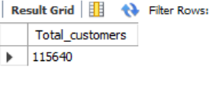

SELECT COUNT(*) AS Total_customers FROM clean_churn

WHERE State = 'MH' AND Gender = 'Male';

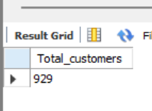

1. Total Churned Customers

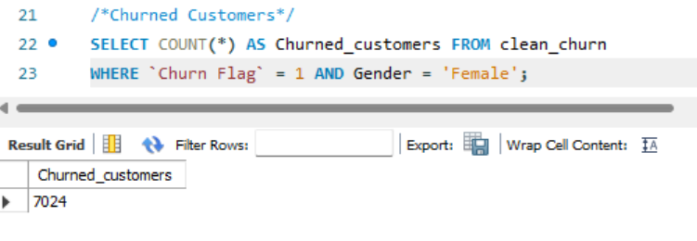

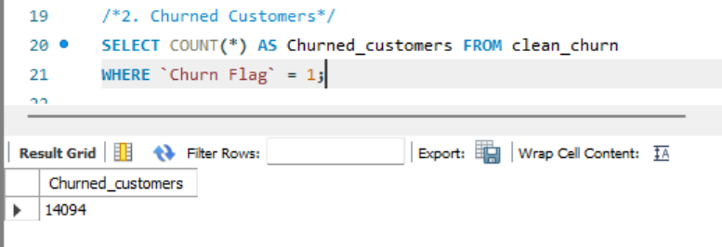

1. Churn Rate %

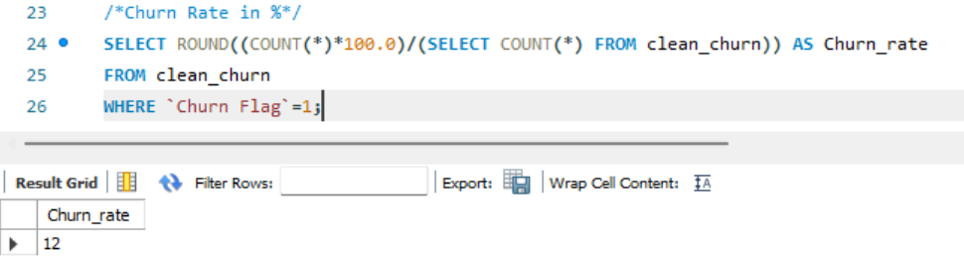

1. Average Credit Score

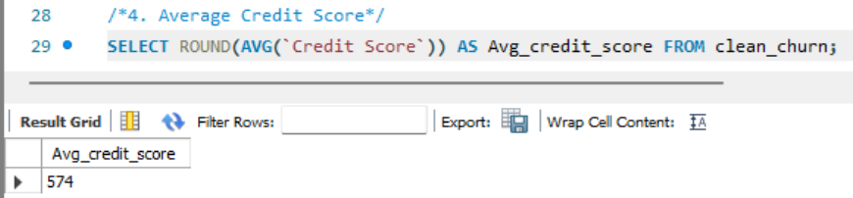

1. Average Customer Balance

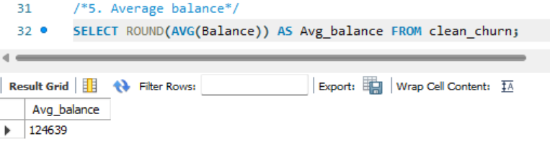

Visual and Charts Queries

1. Churn Rate by Customer Segment

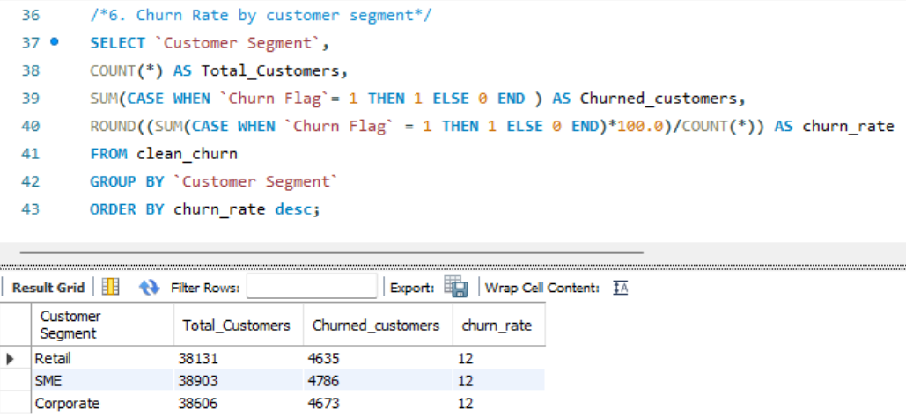

1. Churn Rate by state

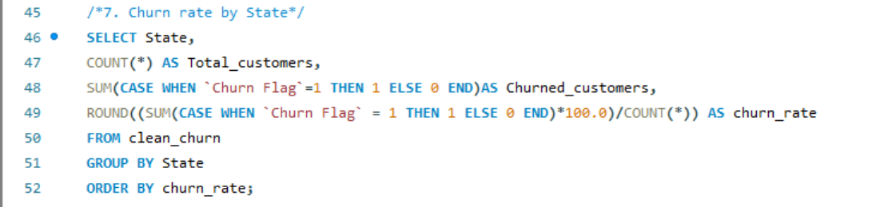

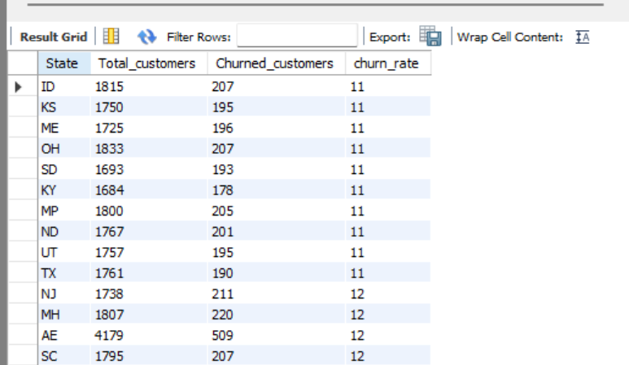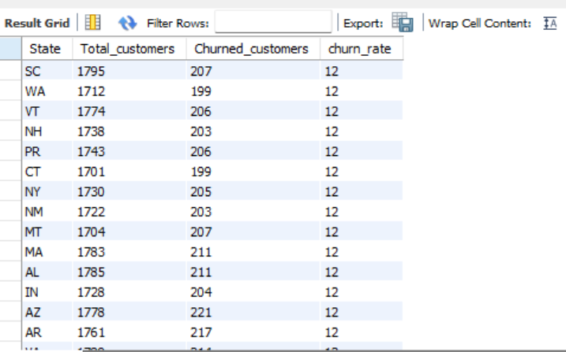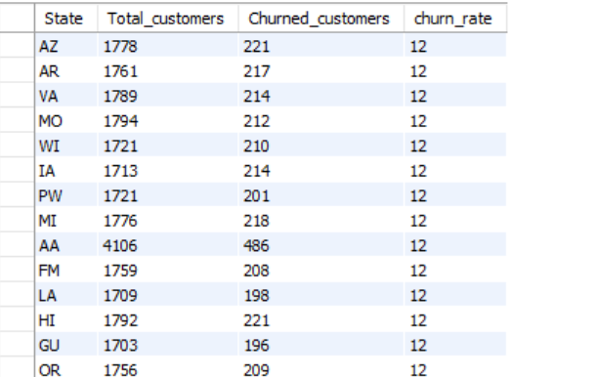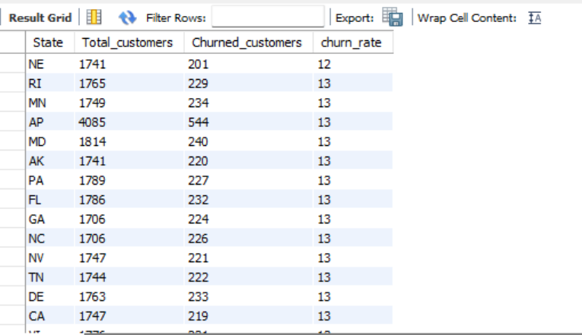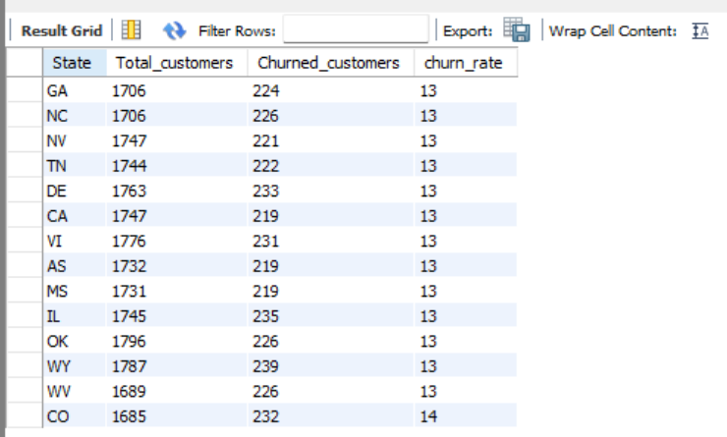

1. Distribution of credit score range

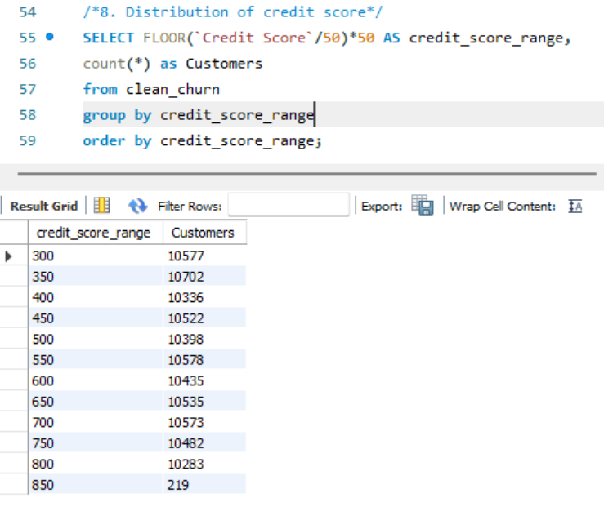

1. Average balance by education level

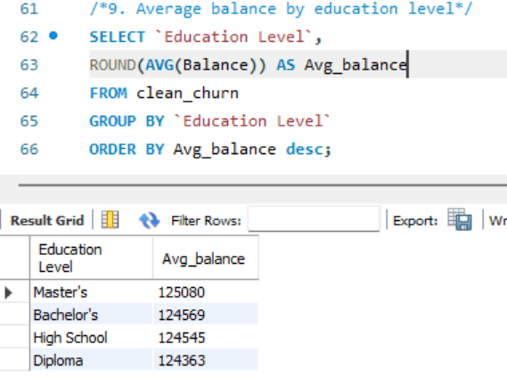

1. **Number of Products Purchased by Churn Status**

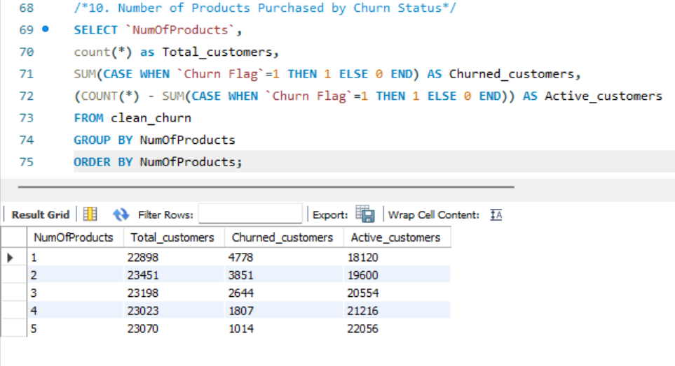

1. **Churn Rate by Occupation Group**

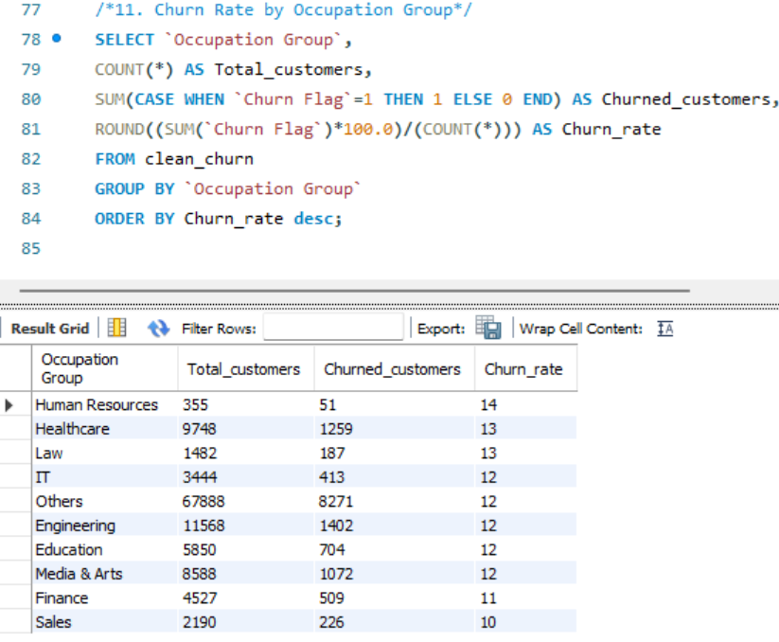

1. Churn Rate by Marital Status

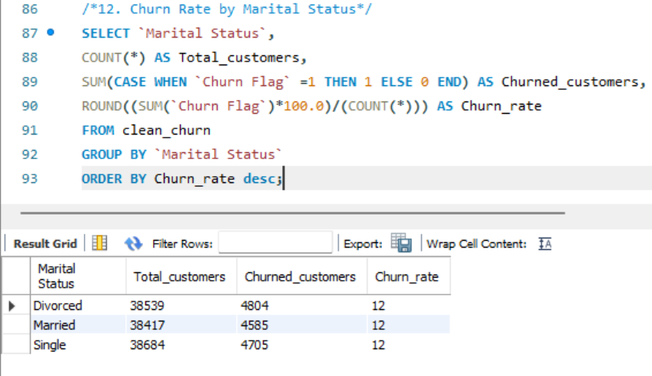

1. Dependents and Churn rate

